- Oil Change Minder Distance/Time Displayed 2019.5 V36x MCA Vehicle Maintenance
Monitor – CGEA1.3

Functional Description

This STSS is used for applications where distance to oil change (miles/kilometers) and time to oil change (shown in days) used instead of %Oil Life remaining. The first application is 2019.5 V36x MCA Diesel applications, however, the applications engineer must verify the actual use of this STSS as per the PDL and powertrain.

All values relative to oil life (distance km/mi or time days) are calculated in ECM/PCM and sent to IPC via
CAN signal.

The PCM shall receive total odometer from the cluster. (Refer to Odometer Indication Display SPSS). (In CGEA applications, the global time will come from the SPDJB). The cluster shall provide a settings screen (IOD) to request oil life reset (to be used after an oil change) to the ECM/PCM. The cluster shall send a CAN signal to the PCM indicating the oil life has been reset.

Interfaces

Interface Context Diagram (I/O Block Diagram)

Figure 1: Oil Change Minder Distance/Time Displayed
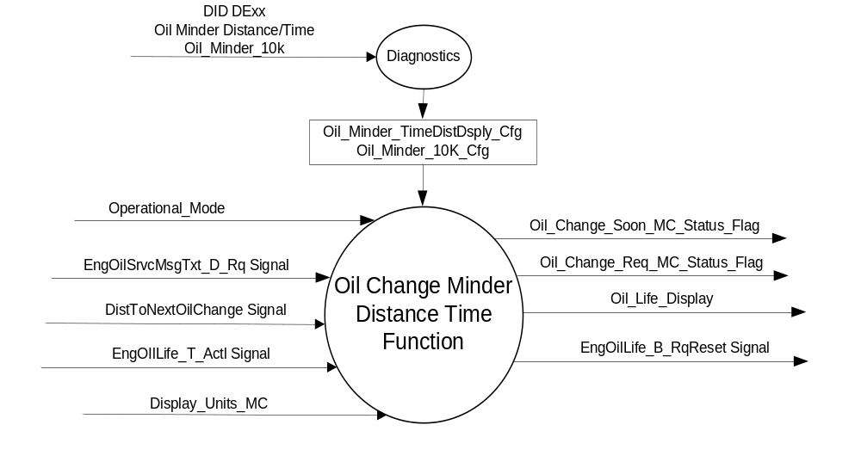

Inputs
      - INTERNAL:
          - Operational_Mode
          - Oil_Minder_10K_Cfg
          - Oil_Minder_TimeDistDsply_Cfg

      - MUX messages on the CAN bus from ECM/PCM

- EngOilLife_T_Actl Signal
Signal Name | Size  (bits) | Detail | Units | Res. | Offset | State Encoded | Min. | Max.
EngOilLife_T_Actl | 11 |  | Days | 1 | 0 |  | 0 (0x0) | 2047 (0x7FF)

- DistToNextOilChange Signal
Signal Name | Size  (bits) | Detail | Units | Res. | Offset | State Encoded | Min. | Max.
DistToNextOilChange | 16 |  | unitless | 1 | 0 |  | 0 (0x0) | 65535 (0xFFFF)

- EngOilSrvcMsgTxt_D_Rq
Signal Name | Size  (bits) | Detail | Units | Res. | Offset | State Encoded | Min. | Max.
EngOilSrvcMsgTxt  _D_Rq | 3 |  | SED | 1 | 0 |  | 0 (0x0) | 7 (0x7)
 |  | NoText |  |  |  |  | 0x0
 |  | ChangeOilSoon |  |  |  |  | 0x1
 |  | ChangeOilNow |  |  |  |  | 0x2
 |  | ResetInProgress |  |  |  |  | 0x3
 |  | ResetComplete |  |  |  |  | 0x4
 |  | NotUsed1 |  |  |  |  | 0x5
 |  | NotUsed2 |  |  |  |  | 0x6
 |  | NotUsed3 |  |  |  |  | 0x7

Outputs
- Oil_Change_Soon_MC_Status_Flag that is used to control the Warning displayed in the message center.
- Oil_Change_Req_MC_Status_Flag that is used to control the Warning displayed in the message center.
- MUX message on the CAN bus to the ECM/PCM:

- EngOilLife_B_RqReset Signal
Signal Name | Size  (bits) | Detail | Units | Res. | Offset | State Encoded | Min | Max
EngOilLife_B_RqReset | 1 |  | SED | 1 | 0 |  | 0 (0x0) | 1 (0x1)
 |  | No |  |  |  | 0x0
 |  | Yes |  |  |  | 0x1

Function/Performance

Operational Modes

Mode | Differentiating Vehicle Conditions
Sleep Mode | OIL CHANGE MINDER INACTIVE
Limited Mode | OIL CHANGE MINDER INACTIVE
Normal Mode | OIL CHANGE MINDER ACTIVE
Crank Mode | OIL CHANGE MINDER ACTIVE

Voltage Levels

Refer to the Cluster Features Table located in the Operational Modes and Voltage Range Strategies
Section of this SPSS

Human-Machine Interface

Visual

Indicator Graphics / Display Format
Warning and Settings

Indicator Color Coordinates
Reference section COLOR & ILLUMINATION REQUIREMENTS (GRAPHICS)

Indicator Characteristics

Refer to Message Center X Display_Y Button Interface Section, where X and Y are appropriate values in this document.

Audio

No Message Center Warning Chime is associated with this Warning.

Switch Control Logic

Refer to Message Center X Display_Y Button Interface Section, where X and Y are appropriate values in this document, for System Check and Warning behavior.

System Accuracy

Oil Change Minder Function shall be processed by the Message Center so that any human requests are processed within 100 ms of receipt of request.

Operation: Performance and Functional

Subsystem Algorithm Flowchart / State Diagrams

Figure 2: Oil Minder Time/Distance Configurations

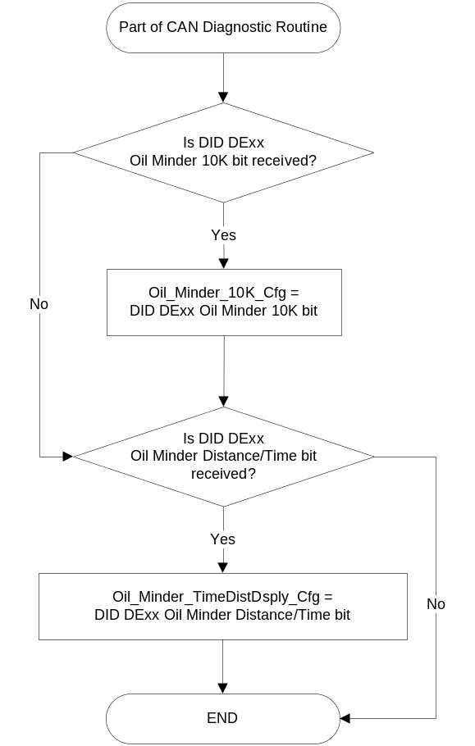

Figure 3: Oil Life Reset Function

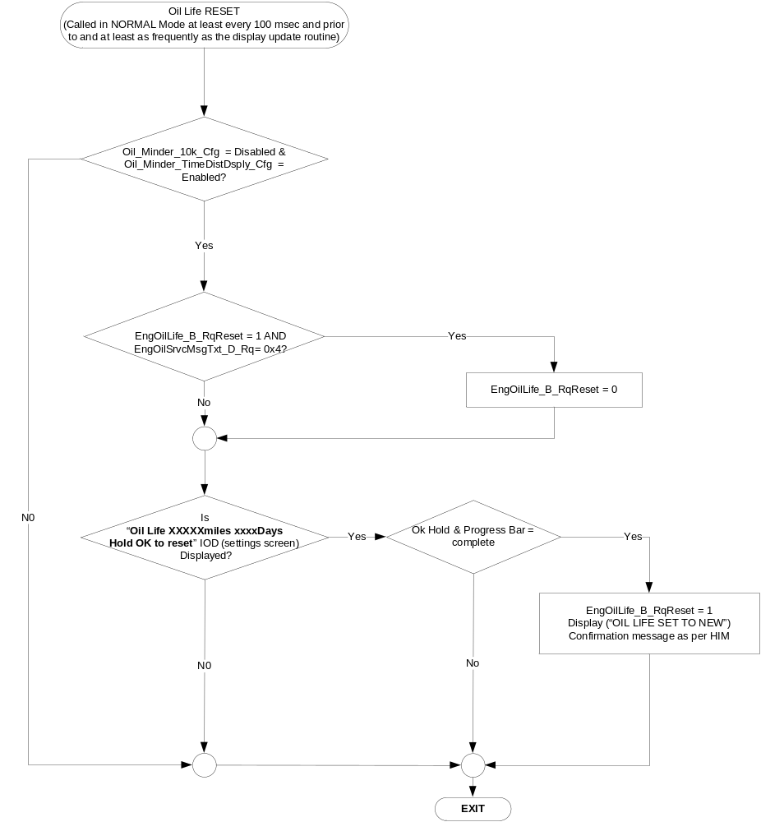

Figure 3: Oil Minder Distance/Time Oil Life Reset Screen
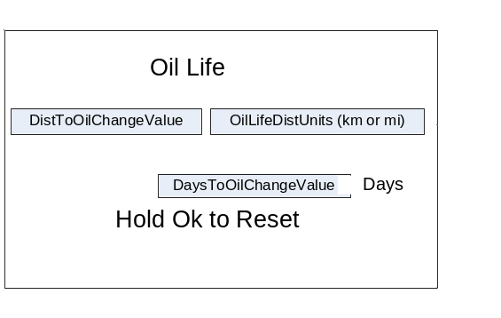
Notes:
- Variable values are as per Tables 1.4,1.5, and 1.6 below. Text and text style will vary as per HMI.
- If VMM_Cfg = Enabled then the screen shown in Figure 3 is drilled down to from the High Level Vehicle Maintenance screen. If VMM_Cfg = Disabled and the above screen is enabled then the above screen if shown will be in a different location as per HMI.

Table 1.4 DistToOilChangeValue
DistToNextOilChange Signal | EngOilSrvcMsgTxt_D_Rq | DistToOilChangeValue  (must support 5 digits)
0 (0x0) - 65535 (0xFFFF) | != 0x4 | Value (DistToNextOilChange)
Not Received l Declared Missing as per 1.4.1 | != 0x4 | Dashes (-----)
X | 0x4 | Dashes (-----)

Table 1.5 DaysToOilChangeValue
EngOilLife_T_Actl Signal | EngOilSrvcMsgTxt_D_Rq | DaysToOilChangeValue  (must support 4 digits)
0 (0x0) - 2047 (0x7FF) | != 0x4 | Value (EngOilLife_T_Actl)
Never Received l Declared Missing as per 1.4.1 | != 0x4 | Dashes (---)
X | 0x4 | Dashes (---)

Table 1.6 OilLifeDistUnits
Display_Units_MC | OilLifeDistUnits
English (0x0 I 0x1) | mi⁽¹⁾
Metric (0x2 I 0x3) | km⁽²⁾
- If language bundle uses mls then use mls instead of mi. Also at the discretion of
HMI group miles may be used instead of mi or mls.
- At the discretion of HMI group kilometers may be used instead of km.

Table 1.7 Oil Change Warning Function
Operational  _Mode | Oil_Minder  _10K_Cfg | Oil_Minder_  TimeDistDsply_Cfg | EngOilSrvcMsgTxt  _D_Rq | Oil_Change  _Soon_MC  _Status_Flag | Oil_Change_Req_MC_Status_Flag
Normal or Crank | Disabled | Enabled | ChangeOilSoon (0x1) | Active | Inactive
Normal or Crank | Disabled | Enabled | ChangeOilNow (0x2) | Inactive | Active
All Other Cases |  |  |  | Inactive | Inactive

Table 1.8 MC_Status_Flag to Message ID (W#)
Oil_Change_Soon_MC_Status_Flag | Oil_Change_Req_MC_Status_Flag | MC Message ID
Active | Inactive | W475
Inactive | Active | W470

Operation Description (supports algorithm flowchart /state diagram)
- This feature is enabled and the associated IOD (settings screen) is shown only if
Oil_Minder_10k_Cfg = Disabled AND Oil_Minder_TimeDistDsply_Cfg = Enabled.

Function Safety Classification (EMC)

Class A

Memory Storage

Parameter Name | Description | Value at  Battery Connect | Value at  Module Wake-up
EngOilLife_T_Actl Signal | Can Signal Sent from ECM/PCM | 0 (0x0) | 0 (0x0)
DistToNextOilChange Signal | Can Signal Sent from ECM/PCM | 0 (0x0) | 0 (0x0)
EngOilSrvcMsgTxt_D_Rq Signal | Can Signal Sent from ECM/PCM | 0 (0x0) | 0 (0x0)
EngOilLife_B_RqReset Signal | Can Signal Sent from IPC | 0 (0x0) | 0 (0x0)
Oil_Change_Soon_MC_Status_Flag | State variable used by M/C Warning Arbitrator | Inactive | Inactive
Oil_Change_Req_MC_Status_Flag | State variable used by M/C Warning Arbitrator | Inactive | Inactive
Oil_Minder_10K_Cfg | Must be set to disabled to allow Oil Minder Distance/Time to be enabled. | Use Stored Value | Use Stored Value
Oil_Minder_TimeDistDsply_Cfg | Used to enable Oil Minder Distance/Time. Note Oil_Minder_10k_Cfg must also be set to Disabled. | Use Stored Value | Use Stored Value
Operational_Mode | 4 state indicator for cluster operational mode | Limited | Limited or Normal or Crank

Prove Out

None.

Reconfigurable Telltale

No

Message Center Msg

See Table 1.8

Error Handling

Missing Message Strategy

The signals will be declared missing as per the Diagnostics section of this SPSS.

DTCs states and history will be determined as per the Diagnostics section of this SPSS.

Diagnostics

Self Test

None

Engineering Test Mode

Reference section “Dealer / Engineering Test Mode (ETM)”

Part II Performance

Supported Diagnostic Trouble Codes (DTCs)
DTC | Description
C10000 | Lost communication with ECM/PCM

DID $DExx
Block  Num | Block Description | Type | Byte(s) | Bits | State: Description | "0" | "1" | Default | Comments/  Information
PACKETED BLOCKS
$xx | Option Content (B&A) | 1 | * | * | Oil Minder 10K | Disabled | Enabled | Enabled | 1 – Enables oil minder displays in cluster. 0 – Disables displays  NOTE: CLUSTER ALWAYS CALCULATES AND TRANSMITS OdometerMasterValue HSCAN SIGNAL REGARDLESS OF CONFIGURATION. (Refer to Odometer Indication Display SPSS).
 |  |  |  |  | Oil Minder Distance/Time | Disabled | Enabled | Disabled | If this is enabled then Oil Minder 10k must be set to disabled

Reference Specification

Revision History

SPSS Module Revision History

Revision Level | Name | Change Description | Date
1.0 | J. Blatchford | Initial Release | 12/20/16

